Press Announcement

Cooperation between the EDAG Group and Baier Motors GmbH: Jointly developed motorcycle for the African target market

Fulda, 3/21/2024 – The EDAG Group, globally leading, independent engineering service provider and Baier Motors GmbH have developed a motorcycle concept for the market in Africa, which, unlike the mid-range products already available there, meets all customer requirements when it comes to robustness, reliability and product features. The next stage of the project will be to finalize the concept development of the new model and put the prototype into series production. Baier Motors is also looking for further investors.

In the current project, Baier Motors from Schleswig-Holstein has enlisted the support of a team of experts. The cooperation with the EDAG Group began in 2022, during the initial planning stage. Working on the basis of the previously defined requirements, concepts for the new motorcycle and the production plant were jointly developed. The two partners then built a mobile prototype with an electric powertrain. Final assembly of the top quality components is to be carried out at various sites in Africa in the future. The first models of the motorcycle should be available to customers in two years – with the option of either a combustion engine or an electric powertrain. Philipp Berchtenbreiter, one of the EDAG Group's motorcycle project leaders, explains the special features of the project: "Using the Oryx concept, we have built a fully functioning motorcycle by means of which it is already possible to experience what Baier Motors GmbH will be bringing to the market in two years' time. The concept bike provides a foretaste of the wide range of other vehicles that can be generated from the modular system. This modularity will enable Baier Motors GmbH to react flexibly to changes in the market."

Optimum solution for individual mobility and greater sustainability
There is a huge demand for individual mobility in Africa, and for many people, having a motorcycle is the ideal way to transport people and goods. Baier Motors will be marketing its new motorcycle in the future to meet precisely this demand. It has a significantly higher payload than its competitors and also offers impressive robustness, reliability and sustainability. As it is based on a long-lasting, robust design in combination with a local supply chain and production, its environmental impact is minimized. With its favourable starting price in line with market requirements, the motorcycle will also be an affordable option for customers. In addition, its first-class design will make it stand out.
Modern sales structure without stores of its own
Baier Motors will not be selling its new motorcycle itself, but through independent local dealers. The idea of entrusting sales to experts in Africa also secures and creates jobs there. For Baier Motors, this is a matter of great importance. The first pre-contract relating to this has already been concluded, others are currently being negotiated.

"We are delighted about this cooperation. In this project, we were looking for a partner with experience, technical expertise and reliability - and have found these requirements to be met in full by the EDAG Group," explains Torben Baier, Managing Director and founder of Baier Motors GmbH. "We are now planning the next steps we need to take to access the large market for our new motorcycle that exists in Africa. In this context, we are currently looking for additional investors who share our vision, to enable us to take the next steps."

Further information can be found here: EDAG Group & Baier Motors – Baierkraft Bike (youtube.com)

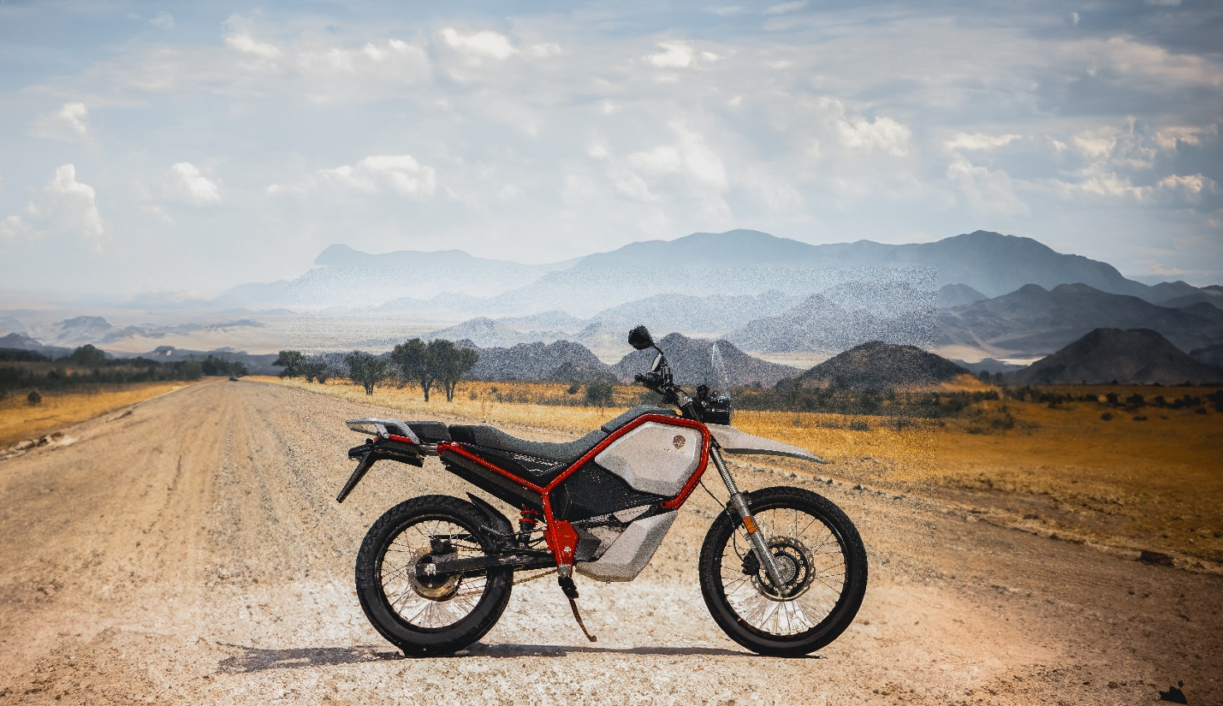

The EDAG Group is developing a drivable prototype for the African market for Baier Motors GmbH. (Photo: EDAG Group)

Do you have any questions, or need further information?
I look forward to hearing from you:
Felix Schuster Head Office
Head of Marketing & Communications EDAG Engineering GmbH
Cell phone: +49 173 7345473 Kreuzberger Ring 40
Email: felix.schuster@edag.com 65205 Wiesbaden
www.edag.com

Torben Baier Head Office
Managing Director Baier Motors GmbH
Email: torben.baier@baiermotors.com Marienthaler Str. 17
Internet: www.baiermotors.com 24340 Eckernförde

About the EDAG Group
EDAG Group is a globally leading, independent engineering service provider that combines excellent engineering with the latest technology trends.
With a global network of some 60 branches, the EDAG Group realizes projects in the Vehicle Engineering, Electrics/Electronics and Production Solutions segments. Drawing on more than 50 years of engineering experience, EDAG's proprietary 360-degree development approach has become a hallmark of quality in the fully integrated development of vehicles and smart factories. The company's interdisciplinary expertise in the areas of software and digitization provides it with crucial skills to actively shape dynamic transformation processes as an innovative partner.
With an interdisciplinary team of around 8,600 experts, the EDAG Group develops unique mobility and industrial solutions for customers that include the world's leading automotive and non-automotive companies. The company is listed on the stock exchange since 2015 and generated revenues of € 796 million in 2022.
For more information, see the EDAG Group website: www.edag.com

About Baier Motors GmbH
Baier Motors GmbH is a startup company with its head office in Eckernförde, Germany. The company aims to offer innovative mobility solutions in developing countries, and to provide high-quality products at affordable prices.

