Press Announcement

EDAG Group Wins Sustainability Award 2023 in Automotive Sector
Award winner: EDAG Group's innovative vehicle platform and zone-based EE architecture
Berlin, March 29, 2023 The EDAG Group's innovative, modular and reusable vehicle platform KOSEL and zone-based electrics/electronics architecture ZOBAS have now won an award. The focus of the Sustainability Award in Automotive is on the responsible use of existing resources for future-proof and sustainable mobility. The award in the Full Vehicle category recognizes the innovative strength of the EDAG Group and its ambitions to significantly reduce the environmental impact of the automotive industry.
"For us as a company, sustainability means reinventing mobility in parts. To this end, we actively initiate and invest in research projects in the fields of sustainable production and mobility," explains Cosimo De Carlo, director and CEO of the EDAG Group. "We are delighted that our research work has been given the Sustainability Award in Automotive 2023, and recognized accordingly."
Vehicle production is still currently causing particularly high emission levels. One of the reasons for this is the tendency to produce new components and parts. This is not, however, always necessary – components with a long service life can be reused over several vehicle life cycles. Modular vehicle design (subject of the KOSEL research project) simplifies disassembly, therefore making it easier to replace components and modules. However, in order to be able to benefit from the advantages this brings, e.g. a longer overall service life and reduced carbon footprint, both the mechanical design and the vehicle's electrical and electronic systems (subject of the ZOBAS research project) need to be designed to meet these requirements.
The KOSEL demonstrator is to be officially presented and exhibited for the first time at the Hannover Show (April 17 - 21). The exhibit can be seen in Hall 16, Stand A12 at the stand of project partner Fraunhofer IWU.
Gerhard Becker, Head of E/E Vehicle Engineering Electronics and leader of the ZOBAS project, traveled to Berlin to receive the award: "For the EDAG Group, mobility engineering also means sustainable engineering. With our know-how of new technologies and concepts, we demonstrate the fact that we are making a contribution to sustainable development in the automotive industry. Our aim now is to put the advantages of this prize-winning technology to use in future vehicle development projects.”
Further information on the projects:
KOSEL is a new kind of extremely long-lasting vehicle platform which makes it possible to produce a wide range of vehicles using a single, modular architecture. The idea is to reduce the environmental impact of vehicle production throughout the entire life cycle by using standard interfaces, which will make it easier to replace components. The platform works on the principle of reuse, making the production of new components superfluous. The project was a joint undertaking involving the following partners: INVENT GmbH, Fraunhofer IWU, Röchling EP, BSMRG GmbH, the Emden-Leer University of Applied Sciences and Dresden University of Technology, and was funded by the Federal Ministry of Education and Research (BMBF).
ZOBAS has revolutionized the electric and electronic architecture of a vehicle not by interconnecting the individual sensors and actuators according to function, but by classifying them into zones based on the vehicle topology. The sensors and actuators in the zone are then connected to the zone controllers, regardless of function. The zone controllers communicate with one another via a redundant automotive Ethernet network. As a result of this reorganization, the weight of the wiring harness is reduced by up to 30 percent. Designed in a joint undertaking with Technica Engineering GmbH and sponsored by BMWK, the system has another advantage, namely that it enables components to be replaced with great ease, making it ideal for use in combination with the KOSEL module.

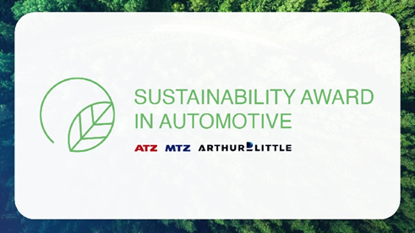
EDAG Group Wins Sustainability Award 2023 in Automotive Sector. (Photo: Laurin Schmid)

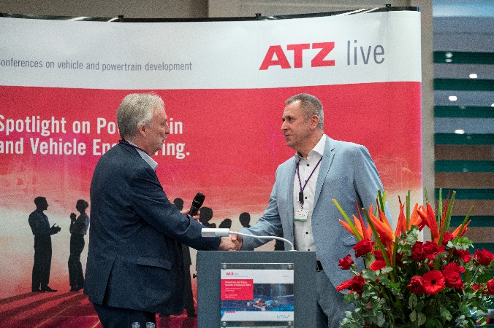
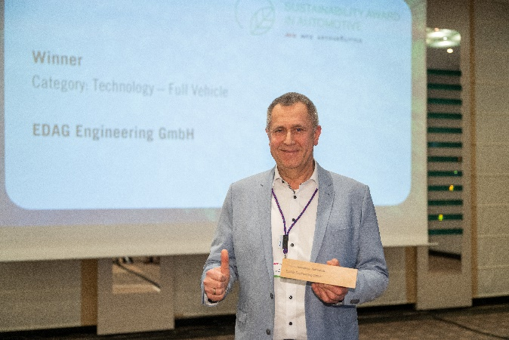
Gerhard Becker, Head of E/E Vehicle Engineering Electronics and leader of the ZOBAS project, traveled to Berlin to receive the award. (Photo: Laurin Schmid)

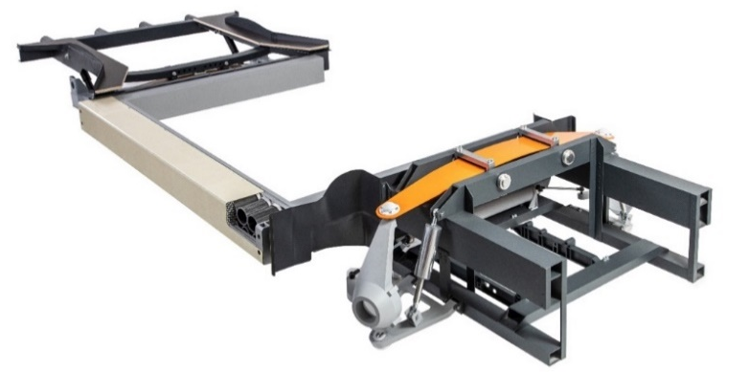

KOSEL platform demonstrator (Photo: EDAG Group)

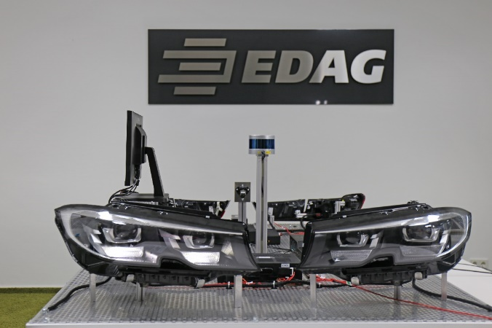
ZOBAS architecture demonstrator (Photo: EDAG Group)

About EDAG
EDAG is the world's largest independent engineering service provider to the global mobility industry.
We regard mobility as a fully integrated ecosystem, and offer our customers technological solutions for more sustainable, emission-free and intelligently networked mobility.
With a global network of some 60 branches, EDAG provides engineering services in the Vehicle Engineering, Electrics/Electronics and Production Solutions segments.
With our interdisciplinary expertise in the fields of software and digitalization, we possess the key skills to help actively shape the dynamic transformation process the mobility industry is currently undergoing. Digital features, autonomous driving, artificial intelligence, alternative powertrains, new mobility concepts and the vision of a networked smart city have become an integral part of our portfolio. Embedded in EDAG's own 360° degree approach to the development of complete vehicles and production facilities, we are a competent partner for sustainable mobility projects. It is in the DNA of the company to actively shape the future of mobility and transfer new technologies and concepts into series production. Today, EDAG is one of the TOP 20 IT service providers in the German mobility sector.
Our customers include leading international OEMs, tier 1 suppliers and startup companies from the automotive and non-automotive industries, all of whom we serve globally with our workforce of approximately 8,000 experts in 360-degree engineering.
In 2021, the company generated sales of € 687 million. On December 31, 2021, EDAG employed a global workforce of 7,880 (including apprentices).

Do you have any questions, or need further information?
I look forward to hearing from you:
Felix Schuster Head Office
Head of Marketing & Communications EDAG Engineering GmbH
Cell phone: +49 173 7345473 Kreuzberger Ring 40
Email: felix.schuster@edag.com 65205 Wiesbaden
www.edag.com

