Press Announcement

EDAG Group: Enormous growth opportunities in new industries

12/19/2023 Fulda – The EDAG Group, engineering service provider to the global mobility industry and a technology developer for industrial solutions, focuses more and more on sectors outside the mobility industry. The reason for this is the increasing growth potential, for example in the semiconductor and chemical industries.

Coming from the automotive world, the efficient planning, design, optimization and implementation of smart factories and their production facilities, and the associated networked product development, is a quality guarantee of the EDAG Group. For years, customers have relied on the development partner, which scores points for its qualifications, company size, financial stability and international location structure.
Dirk Keller, Managing Director of EDAG Production Solutions, is responsible for the strategic orientation and further development of industrial production solutions. "As an engineering service provider, we are not an OEM or plant manufacturer that is primarily focused on selling its products. As an independent company, we can look for the best and most efficient solutions on the market in order to optimally meet customer requirements," emphasizes Keller. "Additionally, we develop and implement customized solutions for areas where there is still no adequate alternative on the market."

EDAG Group Managing Director and CEO Cosimo De Carlo adds: "With our company EDAG Production Solutions, we advise customers and realize complex projects for them in the field of smart factories and manufacturing plants. We are familiar with the challenges, legal requirements and, of course, all relevant issues relating to our customers' production, and are able to provide optimum support for the reorganization or optimization of their plants.

Knowledge transfer from the automotive industry to other industries
Over the last 20 years, the automotive industry has developed into a highly automated and standardized production process.

Other industries can benefit immensely from the sector's experience. This also applies to the semiconductor industry, for example. Since the coronavirus pandemic, the demand for and production of chips has increased enormously due to growth in information and telecommunications technology products. Increasing electrification and digitalization of all areas of life will ensure growth in the semiconductor industry in the long term: new semiconductor production facilities are being built almost all over the world. "The EDAG Group benefits from these market developments. The semiconductor industry currently accounts for 20 percent of our subsidiary Production Solutions' revenue - and this is set a growing trend. Our experience from the automotive industry is extremely helpful here," adds Keller. In addition to the semiconductor industry, medical technology is also a growing sales area. Both industries have very high safety and cleanliness standards, and in both industries the clean room is of great importance both for production and for the construction of the plant technology. We have built up a high level of expertise in this area and have already implemented large-scale customer projects for well-known groups in both industries."

International production networks are particularly interesting and highly scalable for companies. The EDAG Group has a long-standing practice of starting the roll-out in a production facility in Europe. The resulting experience will be used to roll out the system to other plants. EDAG's strong sales structure in Europe, with an international team of experts at around 60 locations worldwide, is key to this. The EDAG Group makes use of its local knowledge to respond to individual customer requirements, always monitoring market developments and evaluating new market potential in these industries. This also includes the American market, where the EDAG Group will continue to expand its sales activities in the coming years.
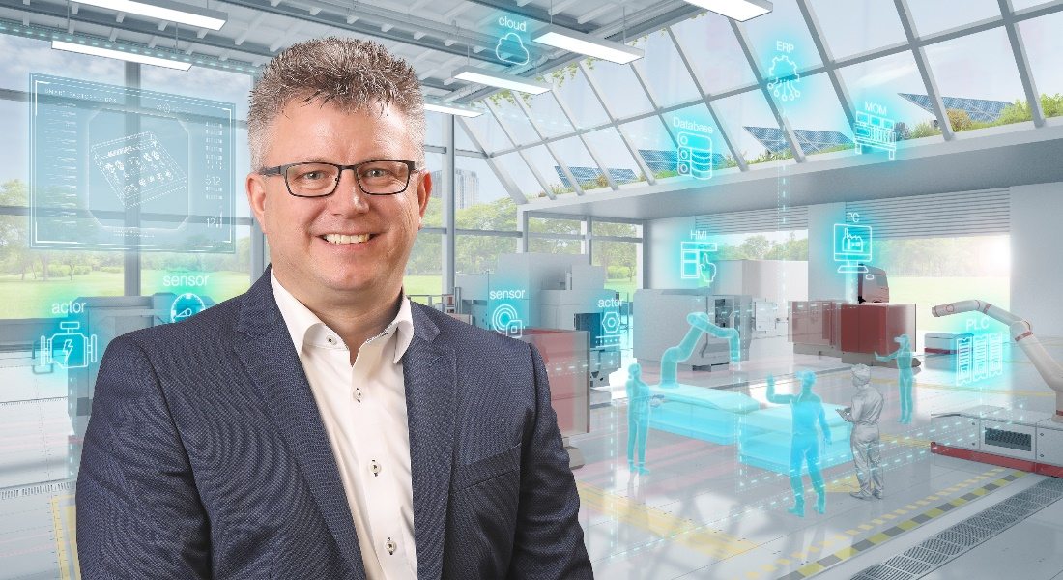
Picture Subtitle: Dirk Keller is responsible for the strategic orientation and further development of industrial production solutions at the EDAG Group. (Photo: EDAG Group)

About the EDAG Group
EDAG Group is a globally leading, independent engineering service provider that combines excellent engineering with the latest technology trends.
With a global network of some 60 branches, the EDAG Group realizes projects in the Vehicle Engineering, Electrics/Electronics and Production Solutions segments. Drawing on more than 50 years of engineering experience, EDAG's proprietary 360-degree development approach has become a hallmark of quality in the holistic development of vehicles and smart factories. The company's interdisciplinary expertise in the areas of software and digitization provides it with crucial skills to actively shape dynamic transformation processes as an innovative partner.
With an interdisciplinary team of around 8,600 experts, the EDAG Group develops unique mobility and industrial solutions for customers that include the world's leading automotive and non-automotive companies. The company is listed on the stock exchange since 2015 and generated revenues of € 796 million in 2022.
For more information, see the EDAG Group website: www.edag.com
Do you have any questions, or need further information?
I look forward to hearing from you:
Felix Schuster Head Office
Head of Marketing & Communications EDAG Engineering GmbH
Cell phone: +49 173 7345473 Kreuzberger Ring 40
Email: felix.schuster@edag.com 65205 Wiesbaden
www.edag.com

