Press Announcement

Hacking for all they were worth: HACKATHON FULDA 2022
EDAG Group supports the fourth 25-hour contest in the Fulda region – Team Slackoverflow wins

Fulda, November 4, 2022 Almost 80 participants traveled to the cathedral city last weekend to demonstrate their skills in this year's Fulda HACKATHON. This was the fourth time the contest was held. This year, the "Slackoverflow" team won the expert jury over with its technical fitness solution. When the eight-strong team returned home on Sunday, they took with them € 2000 prize money. A strong network consisting of regional companies, institutions and public partners are what distinguish the event. The EDAG Group, independent engineering service provider to the mobility industry, has been involved as an organizer and sponsor since the first time the contest for new ideas was held.
Under the motto "hacks 'n health", the search was on this year for smart solutions for the growing market of health and fitness services. Heiko Herchet, EDAG Group Vice President and co-organizer, reports on the HACKATHON FULDA weekend: "Congratulations to Slackoverflow". Their solution, SportSwipe, is not simply a platform for sports services: it also actively motivates users to join in. This is what won the jury over. The main reason behind the decision was that they had the most coherent overall concept in all categories: Team website, product pitch and code quality – the team's performance was outstanding."
Second place was awarded to "Team 1", while third place went to the team "MetaPumking". The audience award was won by the team "DT Health". "Once again, many young talents traveled to Fulda this year, to search for innovative solutions for our digital, networked lives," emphasizes Heiko Herchet. "Especially in the field of digital health, there is great potential for IT solutions. This was demonstrated in no uncertain terms by each of the nine participating teams. I would like to express my unqualified praise of everyone's performance. We are proud to have supported the format as both an organizer and a sponsor since the contest was established in 2019."
The Fulda Hackathon is once again set to be a permanent fixture in Region Fulda GmbH's events calendar for next year, too. "We are already looking forward to the next 25-hour hackathon with great anticipation," says Christian Vey, authorized signatory for Region Fulda GmbH. "With over 80 registrations this year, we have already set a new record. We are eager to see how many young talents we can motivate to take part in the 2023 Fulda Hackathon."

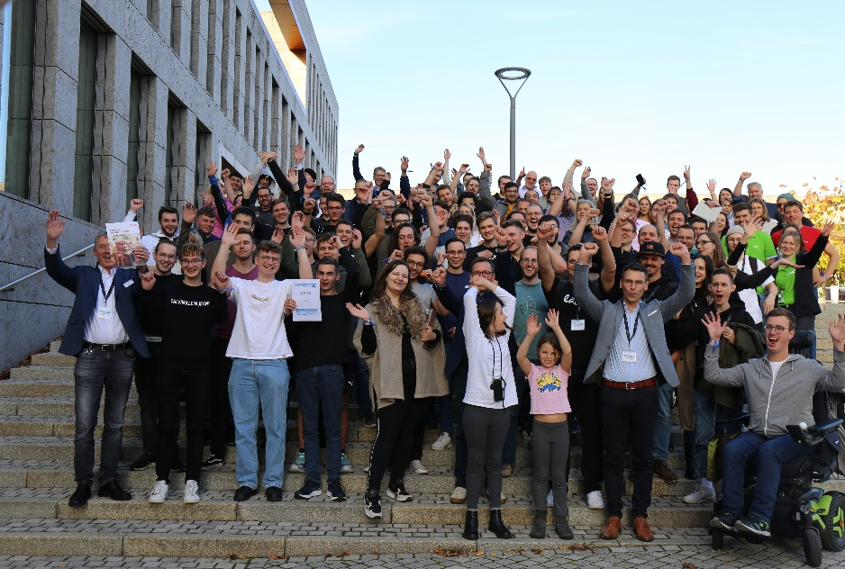

Caption: Over 80 young talents made their way to the University of Fulda last weekend, to joint together and develop smart solutions for health and fitness. Photo: EDAG Group
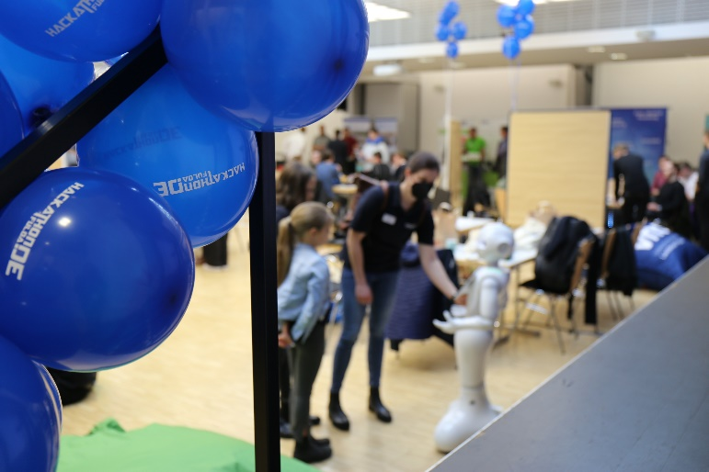
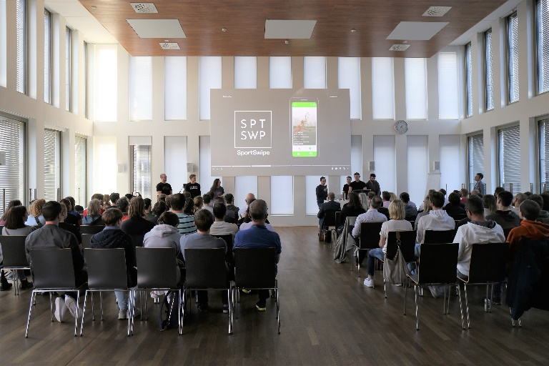
Caption: The winning team, Slackoverflow,
presents its application, SportSwipe, to the jury.
Photo: EDAG Group

About EDAG
EDAG is the world's largest independent engineering service provider to the global mobility industry.
We regard mobility as a fully integrated ecosystem, and offer our customers technological solutions for more sustainable, emission-free and intelligently networked mobility.
With a global network of some 60 branches, EDAG provides engineering services in the Vehicle Engineering, Electrics/Electronics and Production Solutions segments.
With our interdisciplinary expertise in the fields of software and digitalization, we possess the key skills to help actively shape the dynamic transformation process the mobility industry is currently undergoing. Digital features, autonomous driving, artificial intelligence, alternative powertrains, new mobility concepts and the vision of a networked smart city have become an integral part of our portfolio. Embedded in EDAG's own 360° degree approach to the development of complete vehicles and production facilities, we are a competent partner for sustainable mobility projects. It is in the DNA of the company to actively shape the future of mobility and transfer new technologies and concepts into series production. Today, EDAG is one of the TOP 20 IT service providers in the German mobility sector.
Our customers include leading international OEMs, tier 1 suppliers and startup companies from the automotive and non-automotive industries, all of whom we serve globally with our workforce of approximately 8,000 experts in 360-degree engineering.
In 2021, the company generated sales of € 687 million. On December 31, 2021, EDAG employed a global workforce of 7,880 (including apprentices).

Do you have any questions, or need further information?
I look forward to hearing from you:
Felix Schuster Head Office
Head of Marketing & Communications EDAG Engineering GmbH
Cell phone: +49 173 7345473 Kreuzberger Ring 40
Email: felix.schuster@edag.com 65205 Wiesbaden
www.edag.com

