Press Announcement

EDAG Group invests in a competence center for electromagnetic compatibility in Fulda
Increased safety for electrical/electronic components in the automotive, industry, and medical technology sectors
Fulda 27th October 2022 – The increasing complexity of many vehicles calls for more and more components in the motor vehicle. Each individual component generates a more or less strong electromagnetic field that could influence the function of other components in the vehicle. Consequently, state-of-the-art test technologies are required to ensure the road safety and functional reliability of future generations of vehicles. Consequently, the EDAG Group, the world's largest independent engineering service provider to the mobility industry, is investing in a competence center for electromagnetic compatibility (EMC). State-of-the-art test procedures will be implemented in this new test laboratory. Entire vehicles or specific components and their resilience to other electrical or electromagnetic interference factors will be analyzed.
A competence center for electromagnetic compatibility with a total area of 2500 square meters will be constructed for the EDAG Group. Plans call for three different types of absorber halls (a large vehicle hall, a medium-sized vehicle hall, and three component halls) as well as a shielded room with the most advanced technologies and a roller dynamometer. The entire laboratory complex has been defined in line with state-of-the-art technology for maximum flexibility and to meet a wide range of requirements. The EDAG Group is investing for the future and creating additional jobs in the Fulda region. The laboratory will be accredited by the Deutsche Akkreditierungsstelle (DAkkS).
"Electromagnetic comptability is one of the key technical challenges of the future", emphasizes Holger Merz, Managing Director and CFO of the EDAG Group. "With our ultra-modern test center we offer support in determining whether a complete vehicle or a component can withstand the ambient electromagnetic conditions. After intensive testing the customer will receive a summary of the test results in a final report. If it turns out that interference signals are present, the EDAG Group can provide the customer with concrete recommendations for action. To identify interference signals early on in the development phase of vehicles and components, the EDAG Group is also offering a total package: Development of vehicles and components on the basis of electromagnetic compatibly – as a one-stop shop."

The laboratory will be designed for passenger vehicles, trucks, large and heavy industrial trucks, and in addition it will also serve as a safeguard for industrial products and medical products. With the EMC center, the EDAG Group will also be enabled to offer its customers far-reaching product developments for electric motors and batteries.

Harald Keller, COO of the EDAG Group, also highlights the potential of the new laboratory: "With our planned EMC Competence Center we make a clear statement for the further development of the EDAG Group as an innovative shaper of a safe mobility of the future. With increasing electrification the compatibility of electromagnetic fields in a vehicle is a critical safety factor. As a "computer on wheels" systems must reliably perform their tasks, without impacting another (end) device."

The central traffic connections of the Fulda site enables an optimal starting point for these tests. In addition to vehicle manufactures and suppliers, companies in the future core areas of 5G & 6G networks, smart cities, and medical technology will also benefit from what will be one of the most modern centers for electromagnetic compatibility in Europe. Radiated and conducted measurements across all authoritative standards from the commercial, industrial, and automotive sectors will be possible in the various EMC laboratories.

The new laboratory complex will be constructed in the immediate vicinity of the Group's existing buildings in Fulda. The builder will undertake the first demolition activities in the next few weeks.
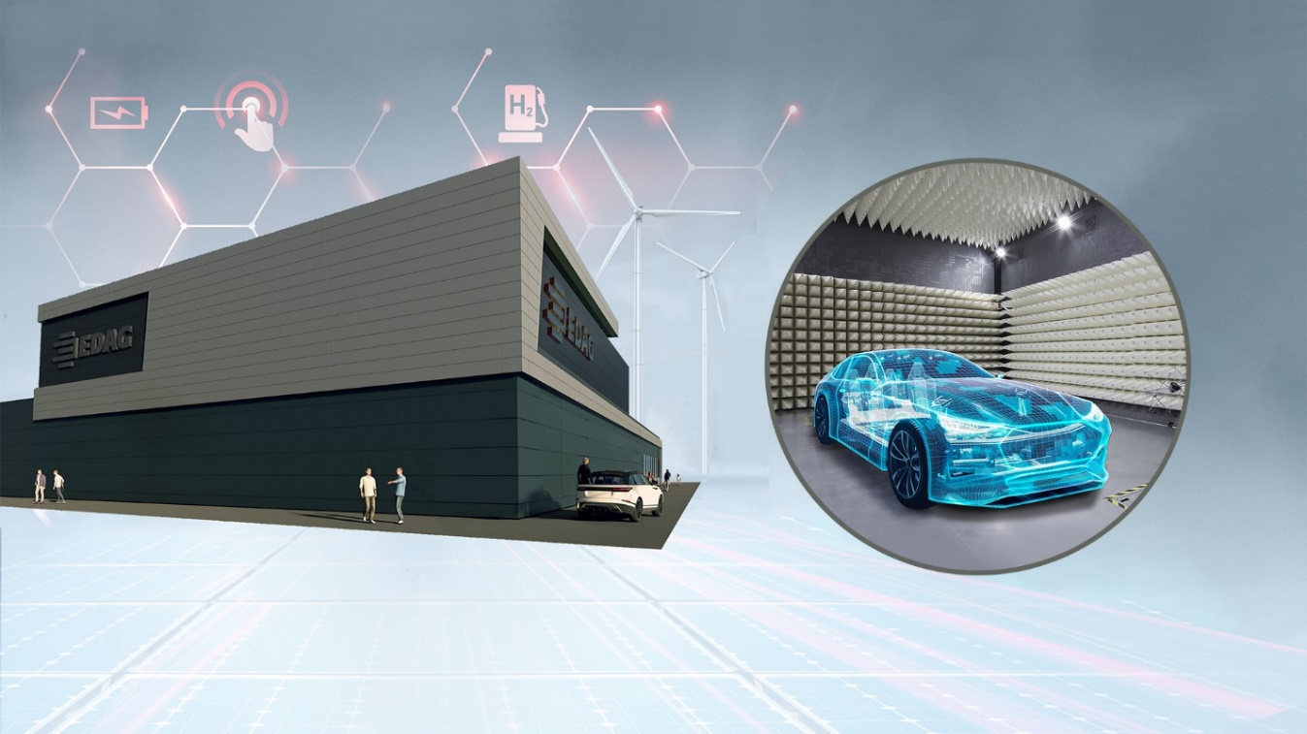
Caption: Ultra-modern EMC Test Center at the EDAG site in Fulda (photo: EDAG Group)
About EDAG
EDAG is the world's largest independent engineering service provider to the global mobility industry.
We regard mobility as a fully integrated ecosystem, and offer our customers technological solutions for more sustainable, emission-free and intelligently networked mobility.
With a global network of some 60 branches, EDAG provides engineering services in the Vehicle Engineering, Electrics/Electronics and Production Solutions segments.
With our interdisciplinary expertise in the fields of software and digitalization, we possess the key skills to help actively shape the dynamic transformation process the mobility industry is currently undergoing. Digital features, autonomous driving, artificial intelligence, alternative powertrains, new mobility concepts and the vision of a networked smart city have become an integral part of our portfolio. Embedded in EDAG's own 360° degree approach to the development of complete vehicles and production facilities, we are a competent partner for sustainable mobility projects. It is in the DNA of the company to actively shape the future of mobility and transfer new technologies and concepts into series production. Today, EDAG is one of the TOP 20 IT service providers in the German mobility sector.
Our customers include leading international OEMs, tier 1 suppliers and startup companies from the automotive and non-automotive industries, all of whom we serve globally with our workforce of approximately 8,000 experts in 360-degree engineering.
In 2021, the company generated sales of € 687 million. On December 31, 2021, EDAG employed a global workforce of 7,880 (including apprentices).

Do you have any questions, or need further information?
I look forward to hearing from you:
Felix Schuster Head Office
Head of Marketing & Communications EDAG Engineering GmbH
Cell phone: +49 173 7345473 Kreuzberger Ring 40
Email: felix.schuster@edag.com 65205 Wiesbaden
www.edag.com

