Press Announcement

EDAG Group integrates innovative hydrogen engine and tank system for Cummins' IAA project
Hydrogen engine as a relevant contribution to climate protection
9/14/2022 Developing competitive, sustainable mobility for the transport, heavy-duty and work machinery sectors is one of the major challenges in the energy transition. Cummins, one of the world's leading manufacturers of power technology, will be presenting a 12-ton Mercedes-Benz Atego truck repowered with a Cummins B6.7H hydrogen internal combustion engine (H2-ICE) at the IAA Transportation 2022 show in Hannover from September 20 - 25. Cummins accomplished the powertrain and fueling system integration in cooperation with the EDAG Group's truck, complete vehicle and hydrogen experts. The proof-of-concept installation exhibited at the IAA demonstrates an exciting development in zero-carbon internal combustion engine technology.
"Hydrogen engines can make a significant contribution to achieving the zero-carbon target, especially where commercial vehicles and mobile machinery are concerned," explains Jim Nebergall, General Manager – Hydrogen Engines at Cummins. "As the industry looks at ways to reduce its environmental impact, these engines are immediately interesting, not just because of the lower cost of conversion compared other zero-carbon options, but because they build on technologies already familiar to vehicle manufacturers, fleet managers and drivers. In addition, conventional drivelines can be utilized with no impact on payload or vehicle performance“.
"In these transformative times, openness to technologies is essential if high-performance alternative drives are to be implemented in all fields of mobility. Especially where commercial vehicles with energy-intensive superstructures and mobile machinery are concerned, the hydrogen engine can be a simple, efficient and climate-friendly powertrain solution," states EDAG Group CEO Cosimo De Carlo. "To this end, we have brought about sustainable H₂ solutions for the powertrain and safe tank systems in collaboration with partners from industry and research, and especially in this project for Cummins."
No radical changes need to be made to the vehicle and drive concept in order to convert a truck, a tractor, a construction or rail vehicle to a climate-friendly hydrogen combustion engine. "We work with an internal combustion engine that has been adapted accordingly. If hydrogen is being used as a fuel, the drivetrain simply needs to be adapted, rather than fully redesigned. A smaller aftertreatment system makes way for hydrogen fuel storage tanks, with the range between refueling sessions based on the number of tanks integrated. These are much easier to position than the heavy batteries used in BEV solutions. The conversion is primarily a matter of hydrogen-specific integration services and domino effects in the overall vehicle, with technological and geometric adjustments," explains Dr. Andreas Quanz, Vice President Sales, Commercial Vehicles at the EDAG Group. "In particular, this benefits manufacturers who carry out tasks that are weight-sensitive and where hydraulics plays a critical role. For them, heavy batteries and not having access to a powerful charging infrastructure detract from the desired performance and cost-effectiveness," continues Dr. Quanz. The zero-carbon hydrogen fuelled proof-of-concept truck presented by Cummins at the IAA Transportation 2022 show is an exemplary case of how different skills and experiences can be brought together. This was crucial for the success of the project.
"Green hydrogen coupled with internal combustion engine technology offers a substantial opportunity to accelerate decarbonzation, and momentum is really growing for this practical solution," adds Jim Nebergall, Cummins‘ General Manager – Hydrogen Engines. Dr. Andreas Quanz sees another major opportunity in sustainable hydrogen engines also being used in other related industries.
What is more, in order to share its experience and expertise in the emerging H₂ market and harness these to increase the pace of innovation, the EDAG Group has joined the 'Allianz Wasserstoffmotor' [Hydrogen Engine Alliance]. This is a cross-sector technology initiative focusing on sustainable transformation. This reflects the EDAG Group's commitment to the advancement of this technology, and provides another element in the mobility of the future.
In addition to the H₂ combustion engine demonstrator, other hydrogen systems developed and constructed by the EDAG Group will also be on display at the show. These include numerous developments carried out in cooperation with NPROXX, a Cummins joint venture and global leader in high-pressure hydrogen storage for stationary and mobile applications. Here, the EDAG Group acts primarily as a developer, integrator and production service provider for storage systems, and also for hydrogen-powered fuel cell vehicles.
The hydrogen engine powered proof-of-concept truck is available to view at Cummins' stand (A12) in Hall 19/20.

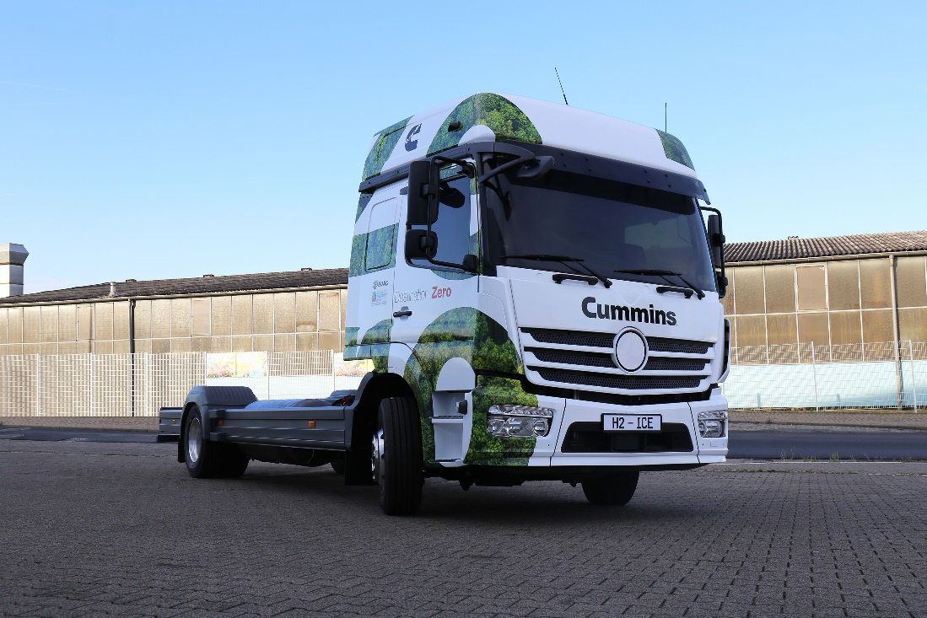
Cummins To Reveal Zero-Carbon H2-ICE Concept Truck At IAA Expo Powered By The B6.7H Hydrogen Engine in collaboration with the EDAG Group (Foto: EDAG Group)

About EDAG
EDAG is the world's largest independent engineering service provider to the global mobility industry.
We regard mobility as a fully integrated ecosystem, and offer our customers technological solutions for more sustainable, emission-free and intelligently networked mobility.
With a global network of some 60 branches, EDAG provides engineering services in the Vehicle Engineering, Electrics/Electronics and Production Solutions segments.
With our interdisciplinary expertise in the fields of software and digitalization, we possess the key skills to help actively shape the dynamic transformation process the mobility industry is currently undergoing. Digital features, autonomous driving, artificial intelligence, alternative powertrains, new mobility concepts and the vision of a networked smart city have become an integral part of our portfolio. Embedded in EDAG's own 360° degree approach to the development of complete vehicles and production facilities, we are a competent partner for sustainable mobility projects. It is in the DNA of the company to actively shape the future of mobility and transfer new technologies and concepts into series production. Today, EDAG is one of the TOP 20 IT service providers in the German mobility sector.
Our customers include leading international OEMs, tier 1 suppliers and startup companies from the automotive and non-automotive industries, all of whom we serve globally with our workforce of approximately 8,000 experts in 360-degree engineering.
In 2021, the company generated sales of € 687 million. On December 31, 2021, EDAG employed a global workforce of 7,880 (including apprentices).

Do you have any questions, or need further information?
I look forward to hearing from you:
Felix Schuster Head Office
Head of Marketing & Communications EDAG Engineering GmbH
Cell phone: +49 173 7345473 Kreuzberger Ring 40
Email: felix.schuster@edag.com 65205 Wiesbaden
www.edag.com

