Press Announcement

Campus FreeCity: Mobility 4.0 in the Real Lab
Starting in 2023, EDAG CityBots are to be used to test mobility and transport services in the Deutsche Bank Park

Fulda, 9/8/2022 Since the beginning of the year, the EDAG Group has been researching a complete ecosystem for mobility, transport and service tasks of a smart city. The site of the real lab is the Deutsche Bank Park. Under the project name "Campus FreeCity", investigations are being carried out to determine how the traffic of the future will be influenced in the long term by new fields of technology such as artificial intelligence, the Internet of Things or autonomous driving. A total of eight partners from science and business are involved. The project is being is being sponsored to the tune of € 10.9 million by the Federal Ministry of Transport and Digital Infrastructure.
The next generation of mobility
In the course of the project, which is to run for 2.5 years, multidisciplinary teams will be working on a comprehensive ecosystem for the efficient, sustainable and user-friendly implementation of a selection of urban mobility and transport tasks and municipal services. Of central importance here are highly automated robot vehicles (EDAG CityBots) which, as a result of their modular structure, can be used for a wide variety of tasks. In order for the networked fleet to be able to prioritize the transport and inspection tasks to be performed, the EDAG Group is also supporting the development of a mobility platform for efficient fleet and task management. The system will first be tested in the Digital Center "Arena of IoT" in the Deutsche Bank Park in Frankfurt am Main during the second half of 2023, and the laboratory phase will last until shortly before the start of the European Championship in 2024. The project will provide municipalities with valuable insights into how urban mobility might work in a smart city in the future.
Variant diversity due to modularity
Initial testing of the autonomous robot fleet will begin in and around the stadium grounds a year earlier. To this end, the EDAG CityBots will be equipped with different modules, depending on the use to which they are to be put. One central scenario is the transport of goods. There is an extremely wide variety of possible applications here: from the transport of food and drinks,and all kinds of waste. On the Deutsche Bank Park's 42-hectare site, where Europa League champions Eintracht Frankfurt are celebrating club history with their latest successes, EDAG CityBots will be able to make a significant contribution to the automation and smartification of the stadium in the course of the research. This is ensured by the specially developed mobility platform. The vehicles communicate with their surroundings, which could mean with stationary infrastructure sensors for watering pitches and landscaped areas, or for handling an ordering and billing system. The integrated control system connects all the main interfaces with one another, in this way also creating new application and business models.
The second central application is the transport of people in the stadium grounds, especially visitors with restricted mobility. "The stadium is ideal for testing robot vehicles in a realistic environment, as we can see many possible mobility and transport applications in the Deutsche Bank Park," says Dr. Oliver Bäcker, Head of EintrachtTech GmbH's Digital Center "Arena of IoT". "The aim we are pursuing here is to transfer the knowledge acquired from the smart stadium to the context of a smart city."
To ensure that the various tasks can be performed using different EDAG CityBot train and utility modules, the company is working on a specific distribution and communication architecture. The innovative avatar is the central communication point for interaction. The EDAG Group is working in close cooperation with the Universities of Darmstadt and Fulda on the design, implementation and validation of the underlying central interaction and processing logic for language, gestures, and symbols. A closed-loop engineering process is also being researched for the EDAG CityBot. The aim is the continuous and automated optimization of the CityBot hardware on the basis of live data, to enable the robot to achieve maximum efficiency in operation and system agility under changing basic conditions.
"By operating the EDAG CityBots in a real-world environment, we will demonstrate that, systematically used and coordinated to interact with humans, robot vehicles can provide socially relevant and lasting benefits. We are looking forward to further developing both our fleet and the ecosystem to go with it in the course of the "Campus FreeCity" project. With strong partners at our side, we would like to play a key role in shaping the future of mobility," says Gerhard Körbel, overall project manager in the EDAG Group's Campus FreeCity project.
Only recently did the EDAG Group and EintrachtTech - independent digital subsidiary of Eintracht Frankfurt, this year's Europa League winners - announce that, within the framework of their partnership, they would also be working together on digitalization-related subjects beyond the immediate scope of the Campus FreeCity research project in Frankfurt's "Arena of IoT". The project team have already concluded the first milestone: completion of the requirements analyses for the development of a real laboratory. Another major step in the Campus FreeCity project is scheduled for September 13: test drives in the Deutsche Bank Park grounds.
About the consortium
The consortium consists of EDAG Engineering GmbH, EintrachtTech GmbH, T-Systems International GmbH, COMPREDICT GmbH, DEKRA Automobil GmbH, the University of Fulda and the Technical University of Darmstadt. House of Logistics and Mobility (HOLM) GmbH is in charge of the overall coordination. The Campus FreeCity project is being is being sponsored to the tune of € 10.9 million by the Federal Ministry of Transport and Digital Infrastructure (BMDV), as part of the AI innovation offensive.

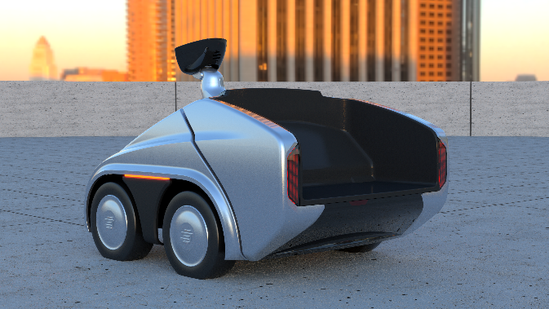
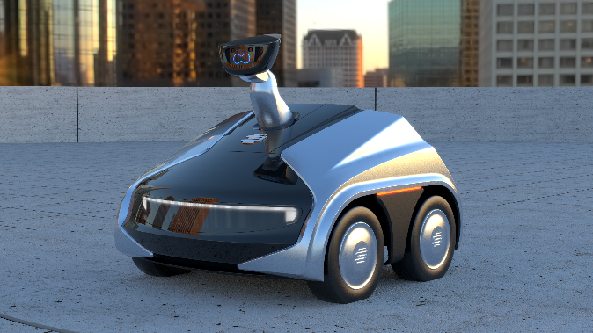
Basic version of the EDAG CityBot
EDAG CityBot for the transport of goods

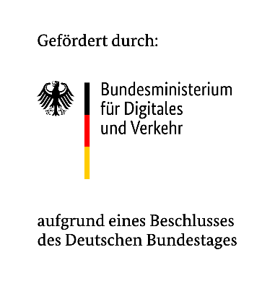
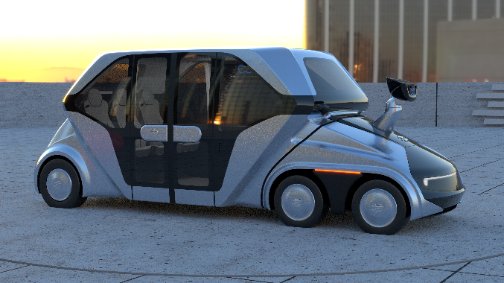
EDAG CityBot for passenger transport

About EDAG
EDAG is the world's largest independent engineering service provider to the global mobility industry.
We regard mobility as a fully integrated ecosystem, and offer our customers technological solutions for more sustainable, emission-free and intelligently networked mobility.
With a global network of some 60 branches, EDAG provides engineering services in the Vehicle Engineering, Electrics/Electronics and Production Solutions segments.
With our interdisciplinary expertise in the fields of software and digitalization, we possess the key skills to help actively shape the dynamic transformation process the mobility industry is currently undergoing. Digital features, autonomous driving, artificial intelligence, alternative powertrains, new mobility concepts and the vision of a networked smart city have become an integral part of our portfolio. Embedded in EDAG's own 360° degree approach to the development of complete vehicles and production facilities, we are a competent partner for sustainable mobility projects. It is in the DNA of the company to actively shape the future of mobility and transfer new technologies and concepts into series production. Today, EDAG is one of the TOP 20 IT service providers in the German mobility sector.
Our customers include leading international OEMs, tier 1 suppliers and startup companies from the automotive and non-automotive industries, all of whom we serve globally with our workforce of approximately 8,000 experts in 360-degree engineering.
In 2021, the company generated sales of € 687 million. On December 31, 2021, EDAG employed a global workforce of 7,880 (including apprentices).
About EintrachtTech
With the founding of EintrachtTech GmbH in the middle of 2019, Eintracht Frankfurt created its own digital subsidiary, which is responsible for all of Eintracht's strategic digital projects. In addition to setting up a digital regional B2C platform, EintrachtTech GmbH is also responsible for the digitalization of the Deutsche Bank Park and for setting up the digital center "Arena of IoT".
In this digital center, partners from industry and research work together to develop digital industrial models from the fields of smart building, facility management, energy management, logistics and mobility for application in the market. And, of course, the stadium is the ideal place to test future-proof digital industrial models for application in the market. There is nowhere else in the state of Hesse where, at any given time, so many people regularly come together in such a confined space as they do at in the Deutsche Bank Park for Eintracht matches or concerts.

Do you have any questions, or need further information?
I look forward to hearing from you:
Felix Schuster Head Office
Head of Marketing & Communications EDAG Engineering GmbH
Cell phone: +49 173 7345473 Kreuzberger Ring 40
Email: felix.schuster@edag.com 65205 Wiesbaden
www.edag.com

