Press Information
EDAG Group at SafetyWeek 2020 - The future of vehicle safety

EDAG Group shows a demonstration of EDAG CityBot and mobile 3D scanner for hardware testing
17.08.2020 - The EDAG Group, the world's largest independent partner for 360 degree engineering in the mobility industry, will be presenting innovations in the fields of mobility, vehicle safety and testing at the SafetyWeek 2020 from 1st to 3rd September 2020 in Würzburg. SafetyWeek is the annual meeting place for the vehicle safety industry. It includes the knowledge congress SafetyUpDate +active, SafetyTesting +active with innovations in testing and simulation, Auto[nom]Mobil, the expert forum on safe urban mobility and the accompanying trade exhibition SafetyExpo. This year's SafetyWeek takes place as a hybrid event that combines the advantages of a presence event and a virtual trade fair. The EDAG Group is platinum sponsor of the event.
The EDAG Group has an impressive and comprehensive expertise and experience in the integrated development of products, production and digital solutions from a single source. In the field of vehicle safety, the company covers the complete portfolio from the concept phase to series production support: the EDAG Group is one of the first service providers to use the new aPLI (advanced Pedestrian Legform Impactor) test body for testing pedestrian protection. The following exhibits will be presented at the SafetyWeek:
- EDAG CityBot: The EDAG CityBot is a multi-functional, fully autonomous robot vehicle with swarm intelligence for the Smart City. Thanks to a large number of backpack and trailer modules, the EDAG CityBot can be configured as required, e.g. as a passenger cell, cargo carrier, city cleaning and waste disposal unit, or for park maintenance.
In conjunction with the platform technology for the Internet of Things (IoT), the EDAG CityBot offers not only new, autonomous transport and working vehicles, but also possible new business models. More information: www.edag-citybot.com
- Mobile 3D scanner for hardware testing: With the hand-held scanner, objects - even those that cannot be reached with conventional measuring devices - can be scanned and digitised within minutes. The EDAG Group uses the 3D scanner in the most varied areas of vehicle safety, for example in overall vehicle testing, passenger protection or child safety. Further information about the various applications can be found on the EDAG Tech Blog (https://insights.edag.com/en/3d-scanner-by-edag).
The Expert Dialogue
The Auto[nom]Mobil session focuses on new forms of mobility such as autonomous driving in urban areas. In this context, Johannes Barckmann, EDAG CityBot Concept & Product Owner, explains in his presentation "EDAG CityBot - a holistic mobility concept for the Smart City of the future" how mobility in the Smart City can be raised to a new level through safe autonomous driving. The presentation will take place on Thursday, 03.09.2020, at 10:50 am.

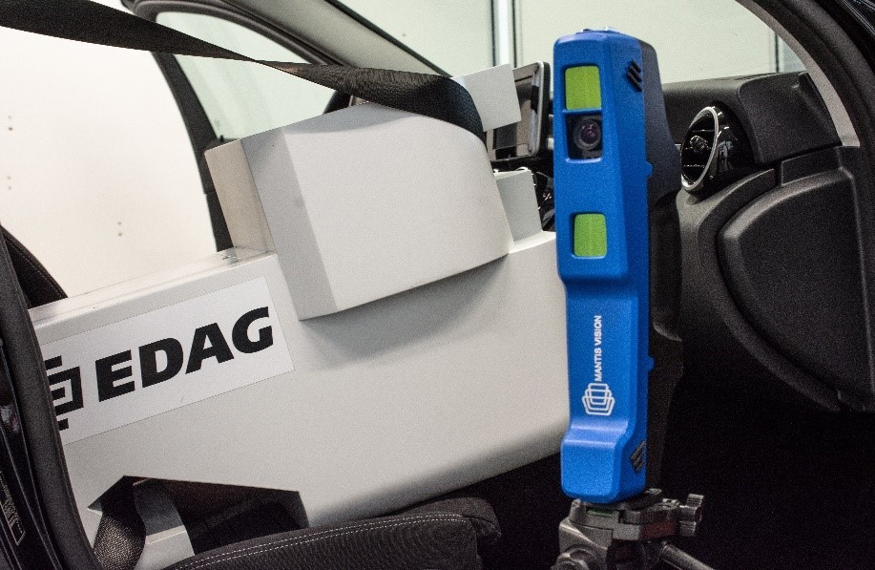
Caption: With the hand-held 3D scanner, the EDAG Group has been breaking new ground in the field of vehicle safety for several months now.

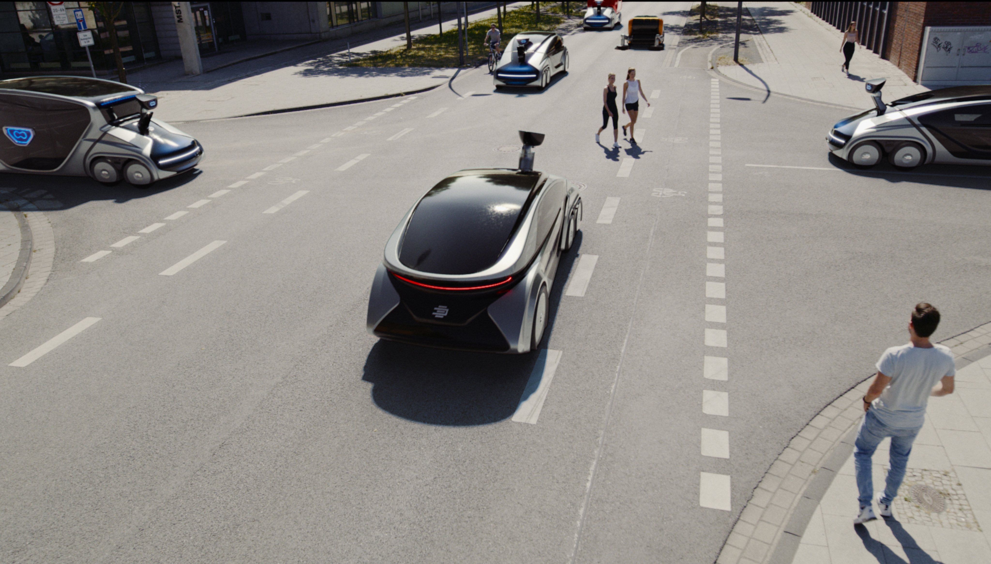
Caption: The EDAG CityBots represent a holistic mobility concept for the Smart City.

______________________________________________________________________
About EDAG
EDAG is an independent engineering service provider working for the global automotive industry. The company has a global network of some 60 branches at the world's major automobile centres to serve leading national and international vehicle manufacturers and technologically discerning automotive suppliers.

In addition, EDAG also offers engineering services in the vehicle engineering, electrics/electronics and production solutions segments.
This extensive competence enables EDAG to provide its customers with all-round support, from the original idea to design, through to product development, prototype construction and even turn-key production systems. As an innovative technological leader, the company also has competence centres for ground-breaking future technologies for the automotive industry: lightweight design, eMobility, digitalisation, integral safety, cyber security and new production technologies.

In 2019, the company achieved a sales volume of € 781 million and an adjusted EBIT of € 33.0 million. On 31st December, 2019, EDAG employed a global workforce of 8,488 (including apprentices).
Do you have any questions, or need further information?
I look forward to hearing from you:

Christoph Horvath Head office
Press Spokesman of EDAG EDAG Engineering GmbH
Tel.: +49 (0) 661- 6000 570 Kreuzberger Ring 40
Mobile: +49 (0) 171- 8765 310 65205 Wiesbaden
E-mail: christoph.horvath@edag.com www.edag.com

