Press Announcement
DTM 2024: EDAG Group and SSR Performance once again take Lamborghini to the starting line
A successful alliance built on years of vehicle development and professional driving skills continues.

Munich, April 16, 2024 - The EDAG Group is to support the SSR Team as its technical partner during the DTM – for the third time in a row. The racing team will be represented this year by Mirko Bortolotti and Nicki Thiim, who will be making his debut. The season kicks off at the Motorsport Arena Oschersleben between April 26 and 28, 2024. Following last year's success, the team will be starting the season with two Lamborghini Huracán GT3 EVO2s. SSR Performance finished the 2023 DTM season as Vice Champion, official Lamborghini driver Bortolotti won the DTM Vice Championship title with SSR Performance this year, and Nicki Thiim is a two-time GTE Pro champion in the World Endurance Championship.
"High-performance vehicles have always been the driving force behind innovations in series development - either be reducing weight, using new materials or through hybridization. Future technologies are often tested first in motorsport, especially in the areas of weight, performance and aerodynamics," explains Harald Keller, COO of EDAG Engineering GmbH. "We are delighted to have SSR Performance as a long-standing partner with whom we can continuously further development and celebrate our successes."
The EDAG Group will be expanding its competencies in the field of vehicle dynamics simulation this year. This May, the Group will be opening the EDAG Zero Prototype Lab in Wolfsburg, a simulation center for the comprehensive testing of vehicles, their functions and their driving dynamics in realistic driving situations. The EDAG Group will be focusing on the latest technological developments and using the Zero Prototype Lab not only for motorsport purposes, but also for complete vehicle development.
"We are delighted to be working with the EDAG Group again this year," says Stefan Schlund, Managing Director of SSR Performance GmbH. "Our collaboration has shown that we can rely on EDAG as a technical partner and that by working together, we achieve the best results."
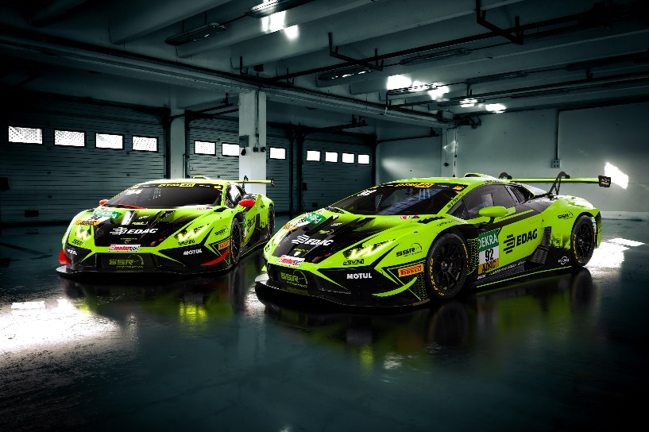
Caption: EDAG Group and SSR Performance continue ´their technical partnership.
About the EDAG Group
The EDAG Group is a globally leading, independent engineering service provider that combines excellent engineering with the latest technology trends.
With a global network of some 70 branches, the EDAG Group implements projects in the Vehicle Engineering, Electrics/Electronics and Production Solutions segments. Drawing on more than 50 years of engineering experience, EDAG's proprietary 360-degree development approach has become a hallmark of quality in the holistic development of vehicles and smart factories. The company's interdisciplinary expertise in the areas of software and digitization provides it with crucial skills to actively shape dynamic transformation processes as an innovative partner.
With an interdisciplinary team of around 8,900 experts, the EDAG Group develops unique mobility and industrial solutions for customers that include the world's leading automotive and non-automotive companies. The company, which has been listed on the stock exchange since 2015, generated sales of € 844 million in 2023. For more information, see the EDAG Group website: www.edag.com
Do you have any questions, or need further information?
I look forward to hearing from you:
Felix Schuster Head Office
Head of Marketing & Communications EDAG Engineering GmbH
Cell phone: +49 173 7345473 Kreuzberger Ring 40
Email: felix.schuster@edag.com 65205 Wiesbaden
www.edag.com

