Press Announcement

Sustainable solutions in 25 hours

EDAG Group supports the "Hackathon Fulda" competition for the fifth time

Fulda, 10/31/2023 - For the fifth time, around 85 participants met over the weekend to put their skills to the test at the HACKATHON Fulda. The competition was all about sustainability this year. A strong network consisting of regional companies, institutions and public partners are what distinguish the event. The EDAG Group, globally leading, independent engineering service provider, has been involved as an organizer and sponsor since the first time the contest for new ideas was held.
This year's challenge was to find smart solutions for the topics of sustainability and climate protection. The teams were allowed to choose between different tasks: How can software be used to reduce energy consumption in buildings? How can data be collected to feed sustainability solutions? And how can making a contribution to climate protection be simplified for users? To complete the challenge, the participants start by forming groups and use the allotted time to generate ideas and then develop prototype products.
Heiko Herchet, Vice President Sales Software & Digitalization at the EDAG Group and co-organizer, explains why the EDAG Group has been involved since the first Hackathon Fulda: "The competition offers a great opportunity to showcase ourselves as a regionally large employer with attractive job opportunities and technical expertise. We do not only provide advice and support to the participants during the 25 hours, but also show them that they could join us after their studies. We're excited to be involved again this year and look forward to supporting and developing the format in the future."
Team "Hackgrid" secured the first place. With their smart solution for building and energy management, the six team members were not only able to convince the jury, but could also take home the prize money of € 2000 sponsored by the EDAG Group. Andreas Schwabauer, Vice President Group Accounting & Tax at the EDAG Group and member of the jury at the Hackathon Fulda, explains the scoring system: "We look very closely at the teams' solutions and evaluate them in terms of their degree of innovation, practical benefits and user-friendliness. Besides the developed code, the presentation of the solution in front of the jury and audience also counts towards the overall evaluation. I was particularly impressed this year with the professionalism of the teams and the focused approach to the three challenges. It's just fantastic to see the motivation and commitment of the participants, who want to achieve the best possible results in terms of sustainability in the available time."
Second place went to team "White Hats"; team "HeatHackers" won third place along with the prize for the best code. "Once again, many young talents traveled to Fulda this year, to search for innovative solutions for our digital, networked lives. An international team with participants from Romania and Belgium was also present at the Hackathon Fulda," emphasizes Heiko Herchet. "Especially in the field of sustainability, there is great potential for IT solutions. This was demonstrated in no uncertain terms by all participating teams."
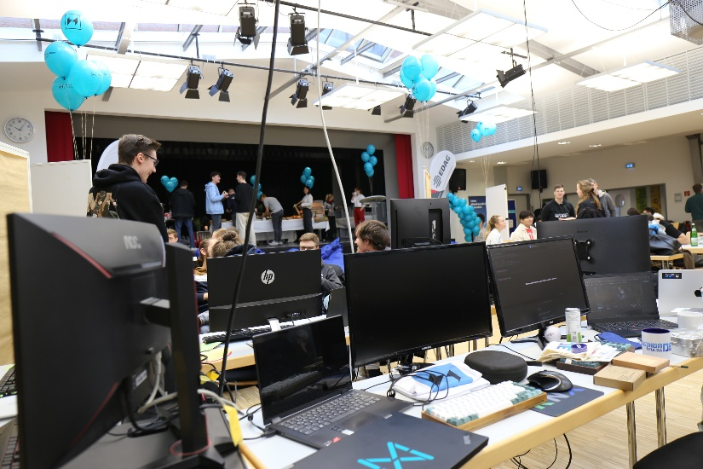
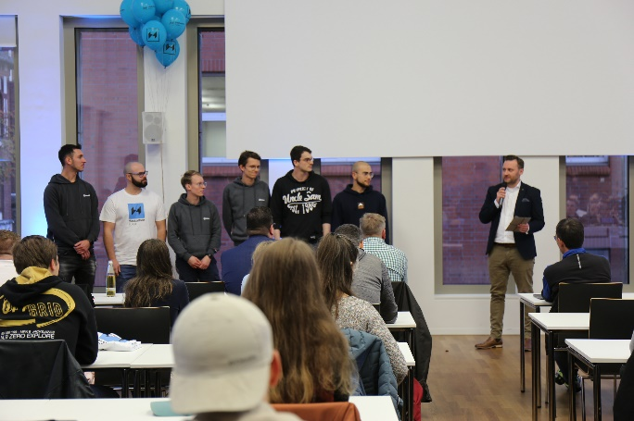
The teams have 25 hours to develop and then present their solution. (Photo: EDAG Group)
Andreas Schwabauer, Vice President Group Accounting & Tax at the EDAG Group and jury member of the Hackathon Fulda with the winning team "Hackgrid". (Photo: EDAG Group)

About the EDAG Group
EDAG Group is a globally leading, independent engineering service provider that combines excellent engineering with the latest technology trends.

With a global network of some 60 branches, the EDAG Group implements projects in the Vehicle Engineering, Electrics/Electronics and Production Solutions segments. Drawing on more than 50 years of engineering experience, EDAG's proprietary 360-degree development approach has become a hallmark of quality in the holistic development of vehicles and smart factories. The company's interdisciplinary expertise in the areas of software and digitization provides it with crucial skills to actively shape dynamic transformation processes as an innovative partner.

With an interdisciplinary team of around 8,600 experts, the EDAG Group develops unique mobility and industrial solutions for customers that include the world's leading automotive and non-automotive companies. The company is listed on the stock exchange since 2015 and generated sales of € 796 million in 2022.

For more information, see the EDAG Group website: www.edag.com

Do you have any questions, or need further information?
I look forward to hearing from you:
Felix Schuster Head Office
Head of Marketing & Communications EDAG Engineering GmbH
Cell phone: +49 173 7345473 Kreuzberger Ring 40
Email: felix.schuster@edag.com 65205 Wiesbaden
www.edag.com

