EDAG Group wins platinum at the BigData Insider Award 2023 in the category IoT Software

Fulda, 10/26/2023 - EDAG Group has won the highest award, the Platinum Medal, in the IoT Software category at the BigData Insider Awards 2023. More than 70,000 readers participated in the vote.

The BigData Insider Awards are presented by seven renowned insider portals, including BigData-Insider and CloudComputing-Insider. They are an annual award that gives readers the opportunity to vote for their favorite IT companies in 42 different categories. The competing companies were previously selected by the insider portals based on their aspirations on the market between 2022 and 2023. The contest saw an impressive turnout, with over 70,000 votes cast by the IT community. The awards were presented on October 26 in Augsburg by the insider portals' chief editors.

EDAG Group was awarded the Platinum Medal in the IoT Software category: a remarkable acknowledgement of its achievements in IoT software development. "We are overwhelmed and proud to accept the Platinum Medal in the IoT Software category at the 2023 BigData Insider Awards," said Heiko Herchet, Vice President Sales Software & Digitalization at EDAG Group. "This is a testament to our team's hard work, innovative spirit and dedication to developing first-class IoT software solutions. We would like to thank our customers and partners for their trust and support that have accompanied us on this journey."

The platinum award at the 2023 BigData Insider Awards solidifies the position of the EDAG Group as a leader in IoT software development and demonstrates the company's commitment to providing innovative solutions to meet the demands of the modern world.

Insight into the BigData Insider Awards ceremony. (Picture: krassevideos.de / VIT)

At the end of an all-around successful awards celebration, all award winners of all insider portals gathered on stage for a group picture. (Picture: krassevideos.de / VIT)

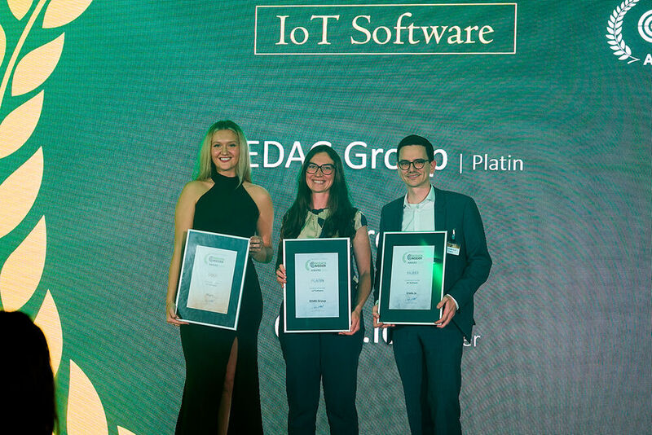
In the IoT Software category, Platinum goes to the EDAG Group, represented by Nathalie Klinger. (Picture: krassevideos.de / VIT)

