Press Announcement

Eurobike 2023: Thinking about mobility holistically
The EDAG Group presents its development expertise to the who's who of the bike industry with the EDAG "Fast Track" bike and an e-Gravelbike made of natural fibers

Frankfurt 06/15/2023 - Premiere at the Eurobike in Frankfurt from June 21 to 25, 2023: The EDAG Group is taking part in the Eurobike with its specialized Bicycle & Pedelec expert team for the first time this year. Two of the company's own bicycle concepts will be presented: The case study EDAG "Fast Track" focusing on a consistent and very iterative prototype development process and the EDAG NFRP e-Gravelbike focusing on sustainability.
As a development partner for the mobiity industry and as a technology developer for industrial solutions, the EDAG Group offers an all-round engineering approach for vehicles, production plants, and also in the field of software and digitalization. From the initial idea, through design, conception, development and prototyping, to validation and testing, more than 8400 experts worldwide work on innovative solutions and technologies across all industries. Now, two examples from the "Bicycle & Pedelec" segment will be shown to the public for the first time at the Eurobike. To create the e-Gravelbike, the EDAG Group collaborated with UBC Composites GmbH, a manufacturer specializing in fiber composites and lightweight construction, and ANYMA Design.

"Gravelbikes are trending. But that's not all that matters. Cyclists have a special relationship to nature," explains Niko Lehtonen, Team Leader Bicycle & Pedelec in the EDAG Group. "The carbon footprint of their means of transportation plays an increasingly important role for them." The frame of the EDAG natural fiber e-Gravelbike, made from flax fibers, meets the highest standards of design and sustainability. Compared to similar carbon or alloy frames not only the carbon footprint can be reduced: Due to the carbon sequestration of the plant in its growth phase, the regionally manufactured frame can even achieve a negative CO2 balance in the best case.

Alongside sustainability, design and components, material selection and processing in particular play a key role in the purchasing decision for quality bikes. "The highest standards of design and manufacturing processes must be met in order to work with sustainable products here," says Lehtonen. For this, the EDAG Group offers comprehensive development and production expertise in the bike segment. "We make use of state-of-the-art simulation and calculation methods from the automotive sector - whether for complex developments such as the EDAG natural fiber e-Gravelbike or for faster development cycles such as the Fast Track. This allows us to facilitate innovations for and with bicycle manufacturers, while also achieving a greater real net output ratio and a significantly more climate-friendly use of resources at the same time. This is a real added value, especially so for smaller bicycle manufacturers that don't have such a development and production background."

In response to more and more requests in the course of the energy and mobility transition, committed bikers at the EDAG Group have initiated the establishment of a department dedicated to this purpose. "With our e-Gravelbike and our Fast Track Bike, we are able to show that we have the highest quality standards when developing bicycles. That is because our team itself consists of enthusiastic "bikers" and we have thus built up a very high level of industry knowledge in the field of bicycles and pedelecs over the past few years. Our slogan: "from bikers - for bikers," says Lehtonen. In the EDAG Group Bicycle & Pedelec team, the bicycle and development experts can draw on not just their own know-how but also on the entire tool and methods portfolio of the EDAG Group. As a result, the EDAG Group can offer a complete all-round service also for bicycle manufacturers and suppliers. With the EDAG natural fiber e-Gravelbike and the EDAG "Fast Track", two results can be seen at this year's Eurobike (Hall 8, booth F40).

More information on the EDAG bike team: www.edag.com/de/branchen/fahrrad-pedelec
More information on ANYMA: Anyma - Anyma Design
More information on UBC: Carbon Fiber Components - Development -Design - Construction - | UBC Composites GmbH (ubc-gmbh.com)
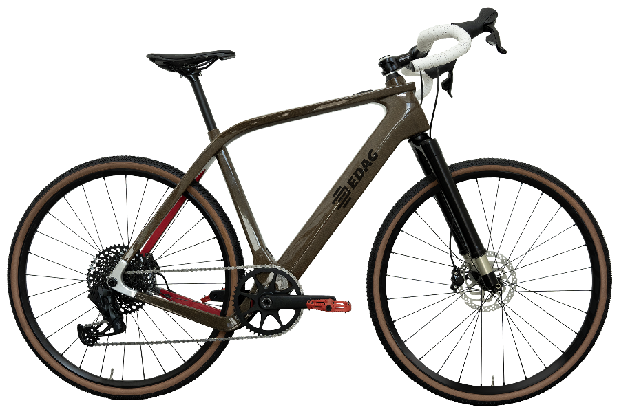
The EDAG Group's e-Gravelbike will debut at Eurobike 2023. (Photo: EDAG Group)

About EDAG
EDAG is the world's largest independent engineering service provider to the global mobility industry.
We regard mobility as a fully integrated ecosystem, and offer our customers technological solutions for more sustainable, emission-free and intelligently networked mobility.
With a global network of some 60 branches, EDAG provides engineering services in the Vehicle Engineering, Electrics/Electronics and Production Solutions segments.
With our interdisciplinary expertise in the fields of software and digitalization, we possess the key skills to help actively shape the dynamic transformation process the mobility industry is currently undergoing. Digital features, autonomous driving, artificial intelligence, alternative powertrains, new mobility concepts and the vision of a networked smart city have become an integral part of our portfolio. Embedded in EDAG's own 360 degree approach to the development of complete vehicles and production facilities, we are a competent partner for sustainable mobility projects. It is in the DNA of the company to actively shape the future of mobility and transfer new technologies and concepts into series production. Today, EDAG is one of the TOP 20 IT service providers in the German mobility sector.
Our customers include leading international OEMs, tier 1 suppliers and startup companies from the automotive and non-automotive industries, all of whom we serve globally with our workforce of approximately 8,400 experts in 360-degree engineering.
In 2022, the company generated sales of € 796 million. On December 31, 2022, EDAG employed a global workforce of 8,412 (including apprentices).

Do you have any questions, or need further information?
I look forward to hearing from you:
Felix Schuster Head Office
Head of Marketing & Communications EDAG Engineering GmbH
Cell phone: +49 173 7345473 Kreuzberger Ring 40
Email: felix.schuster@edag.com 65205 Wiesbaden
www.edag.com

