Press Announcement

Making it to the top with flying colors
EDAG Group apprentice is the best technical product designer in Germany

Fulda / Berlin, May 16, 2023 - The EDAG Group is delighted at an apprentice's outstanding success: Hannah Mey has passed her final exams and emerged as the best technical product designer in Germany, making her the National Champion of the 2022 training year. The awards ceremony in Berlin was hosted by the German Chamber of Industry and Commerce.
The 23-year-old completed her "Technical Product Designer for Product Design and Construction" apprenticeship with above-average grades, which gained her the title of Regional Champion for the State of Hesse. This outstanding performance qualified her to enter the national championships. All 16 Regional Champions were required to take a practical exam consisting of the documentation of a design process, a presentation and a subsequent round of questions posed by the examination board of the Chamber of Commerce. Hannah Mey emerged from the contest as National Champion.
Her outstanding performance has already been recognized and celebrated by EDAG CFO Holger Merz, Dr. Christian Gebhardt, President of the Chamber of Commerce in Fulda and the EDAG Group's training department. She received a check for € 1,500 from her training company. Michael Noll, her training supervisor, and head of department Andreas Farnung are also proud of her excellent results. "It is enormously rewarding to work with such committed and independent young people," praised Noll. On completing her apprenticeship, Hannah Mey was kept on in the Design Studio, where she will work as a surface modeler. The talented young woman aims to start a degree course this fall.
"We, the EDAG Group, are extremely proud to be able to congratulate the best product designer in Germany today," emphasized Holger Merz in his speech. "Your commitment throughout your apprenticeship and your will to give of your very best have paid off: You will be on the stage at the national awards ceremony in Berlin. Enjoy every minute, we are extremely proud of you, and are of course pleased that you will continue to be part of the EDAG family."
This 17th National Chamber of Commerce Awards Ceremony was held at the bcc, Berlin Congress Center. Among the well-wishers were German Chamber of Commerce President Peter Adrian and Federal Employment Minister Hubertus Heil, who gave the official speech. In addition to the award winners and their families, the event was also attended by representatives of the training companies and numerous guests from politics, business and the media. The event was moderated by Thore Schölermann.

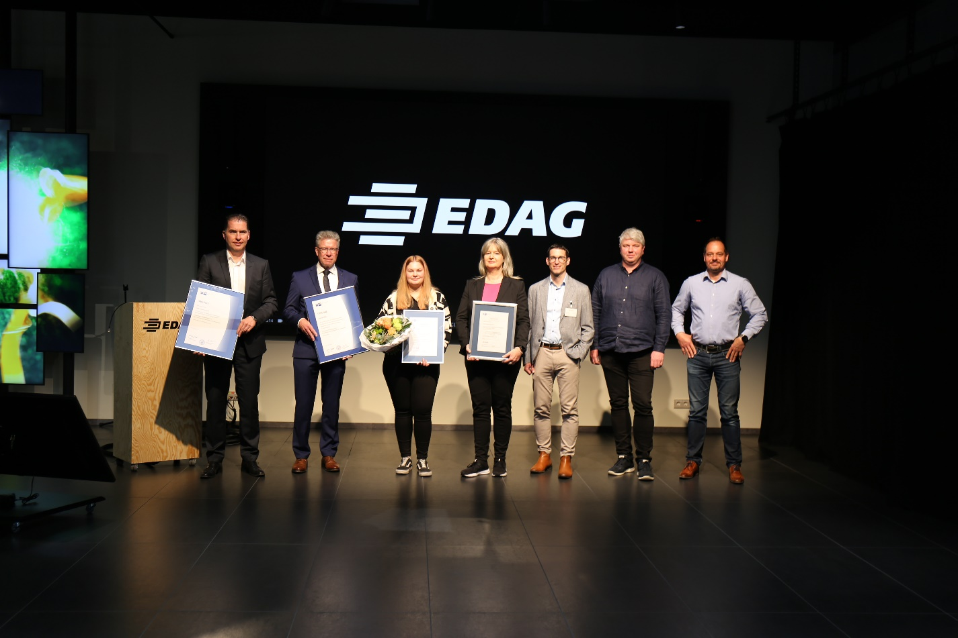

Proud to congratulate Hannah on her success (left to right): Holger Merz (CFO EDAG Group); Dr. Christian Gebhardt (President of Chamber of Commerce and Industry Fulda); Hannah Mey; Susanne Brune (Head of Department Talent- and Performance-Management); Michael Konow (Managing Director Chamber of Commerce and Industry Fulda); Andreas Farnung (Head of Department Design Studio); Michael Noll (training supervisor)

About EDAG
EDAG is the world's largest independent engineering service provider to the global mobility industry.
We regard mobility as a fully integrated ecosystem, and offer our customers technological solutions for more sustainable, emission-free and intelligently networked mobility.
With a global network of some 60 branches, EDAG provides engineering services in the Vehicle Engineering, Electrics/Electronics and Production Solutions segments.
With our interdisciplinary expertise in the fields of software and digitalization, we possess the key skills to help actively shape the dynamic transformation process the mobility industry is currently undergoing. Digital features, autonomous driving, artificial intelligence, alternative powertrains, new mobility concepts and the vision of a networked smart city have become an integral part of our portfolio. Embedded in EDAG's own 360 degree approach to the development of complete vehicles and production facilities, we are a competent partner for sustainable mobility projects. It is in the DNA of the company to actively shape the future of mobility and transfer new technologies and concepts into series production. Today, EDAG is one of the TOP 20 IT service providers in the German mobility sector.
Our customers include leading international OEMs, tier 1 suppliers and startup companies from the automotive and non-automotive industries, all of whom we serve globally with our workforce of approximately 8,400 experts in 360-degree engineering.
In 2022, the company generated sales of € 796 million. On December 31, 2022, EDAG employed a global workforce of 8,412 (including apprentices).

Do you have any questions, or need further information?
I look forward to hearing from you:
Felix Schuster Head Office
Head of Marketing & Communications EDAG Engineering GmbH
Cell phone: +49 173 7345473 Kreuzberger Ring 40
Email: felix.schuster@edag.com 65205 Wiesbaden
www.edag.com

